Competition Letter Home to Parents


Preparing for the Competition
Your student has worked hard for this moment - their first VEX V5 Robotics Competition! This letter will help familiarize you with what to expect at their first event, so you can best support them.

Event Details
- The Event name will be held at location, date, time.
- Students should arrive at time, and will be finished at time.
- Your student should bring money for food/packed lunch/snacks etc.
- The team’s coach is Coach Name. They can be reached at Contact Information in case of emergency.

What to Expect at the Event
- Parts of an Event
  - Inspection is conducted to verify that each team’s robot complies with the rules and specifications outlined in the official Override game manual.
  - Interviews may be a part of any competition, and give the team a chance to demonstrate their ability to explain their robot design and game strategy, and include their engineering notebooks. Interviews are used to help determine awards at some events.
  - Matches include the following periods:
    - 15-Second Autonomous Period: In this 15-second section of the match, the robot executes coded behaviors using a project created by the team.
    - Driving Period In this 1:45 period, students use a Controller to drive the robot to score points. For more information about how Override is scored, view the game manual.
- Matches are played with 2-team alliances. Each 2-team alliance will play against another 2-team alliance. Alliances are randomly generated, until the finals of a match. Students’ communication and collaboration skills will help them to be successful alliance partners. This video explains the alliance selection process for finals.
- Each team will play in an average of 5-8 qualification matches per tournament. Scores in the qualification matches determine which teams will participate in finals.
- VEX V5 Robotics Competitions are run by volunteers. From organizing to judging, roles at events are filled by people who have volunteered their time to make the competition the best possible experience for the teams.
- Awards: There are a number of awards that can be offered at a competition; some of these are based on team performance in matches and are not a part of the judging process. Others judge specific attributes demonstrated by teams, such as sportsmanship or the engineering notebook.

Supporting Your Student during an Event
Being in the audience at a robotics competition is an exciting experience, and your attendance is a fantastic way to show your support. The following guidelines will help ensure that everyone has a good time throughout the entire event.

- Be on Time! Make sure your student arrives at the event on time. Because the matches are played with an alliance, it is extra important that everyone is present so no alliance has to compete alone.
- Make sure you have submitted all required permissions/forms for your student!
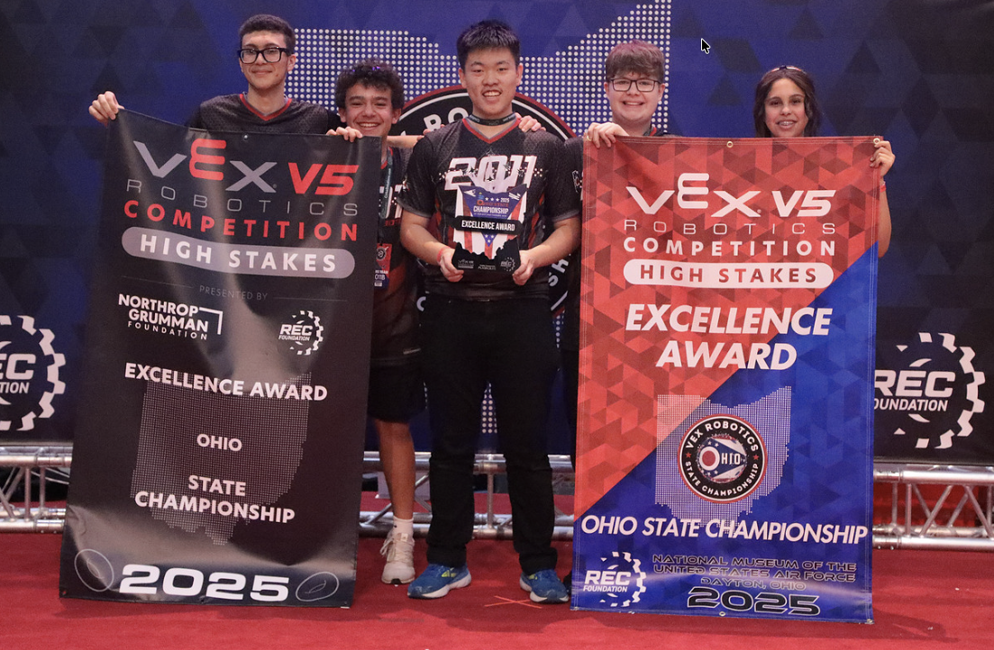
- Keep the Student-Centered Policy in mind. Positive encouragement and cheering your student’s team on during an event is welcomed! Be sure to avoid interfering with judging in any way, or calling out instructions or guidance for the team during a match or interview. Scoring strategy decisions, alliance selection, interview questions and scouting are students’ jobs and parents should not be involved with any of these activities before, during or after the competition.

- Help the team stay positive and focused on learning over winning. Success at a VEX V5 Robotics Competition event is about much more than just a score in a match. Your student’s team showing up and competing is a win in and of itself. Help your team to celebrate all successes, no matter the size, to make the competition day a positive experience for everyone involved.

See you at the Event!
Your support and encouragement of our team is an essential element of our success! We look forward to seeing you at the event, and celebrating all the progress our team has made so far this season. If you have any questions, please don’t hesitate to reach out.

Sincerely,

Coach Signature

